Dumpster Fire
Combat Design Document
Version 1.0

General description 2
Overheat 2
Overheat - Scaling 2
Overheat - Cycles 2
Enemy spawners 3
Orbital Spawner 3
Zone Spawner 4
Boss Spawner 4
Enemies 5
Enemies - Statistics 5
Life 5
Movement speed 5
Damage 5
Drop chance 5
Drop pool 5
Spawn Chance 5
Common Enemies 6
Junk Slime 6
Slime stats 6
Vigilance Drone 6
Drone stats 7
Chaser Bot (Wall-e) 7
Chaser Bot stats 7
Enemy Variants 8
Hellfire Slime 8
Hellfire Slime stats 8
Bomber Drone 8
Bomber Drone stats 8
Shocker Bot 9
Shocker Bot stats 9
Elites enemies 9

General description
In this document there will be an extensive explanation about the core combat mechanics, such as the Overheat mechanic that will co-exist around the world of Dumpster Fire and be core to the player progression.
Enemies will be detailed in this document with all his sub-species and behaviour, this includes normal enemies, normal variants, elites and bosses. All enemies will have a drop chance for the items in game detailed later on.
Finally there will be a detailed graphic of the game map and the different levels on it.

Overheat
Dumpster Fire has an overheat system that surrounds the world and the player, the goal is to achieve a mechanic which determines the combat state for the enemies and sets a "checkpoint" for the player progression.

The overheat will be displayed as a bar which fills by killing enemies from 0% to 100%.
From 0% there will be a constant enemy spawn rate, every quarter of the gauge there will be a spawn of an X number of elites and will stop, only if the gauge reach another quarter the elites will spawn again (25%,50%,75%,100%), at 80% the enemy spawn rate will be greatly increased and be persistent through the 100% mark.

At 100% one of the two bosses will spawn while the spawn rate is still increased, if the player manages to kill the boss then the overheat bar will decrease to 0%.

The overheat gauge will have various weights and will have to be dynamic in order to be fulfilled.

For example: Using arbitrary numbers if the first cycle of the overheat requires a total of 100 units, from 0% to 80% will require 50 enemies killed and the last 80% to 100% will require the same 50 enemies, making the overheat gauge have an extra weight.

Overheat - Scaling
The overheat must have an exponential scaling with a specific function

$previousOverheatAmount*incrementalAmount$

Overheat - Cycles
We aim to have a gameloop of approximately 15-20 minutes maximum where there will be four overheat cycles. The uneven number of cycles will have a powerful wave of elites from different variants and the even number cycles will have the bosses.

Enemy spawners
In Dumpster Fire we will have three types of spawners and spawn rates. Also there must be a weighted randomness that chooses which enemy will spawn. (roulette of enemies)

In the actual build there has to be a limit of only 300 enemies on screen (16/5/2026).

Orbital Spawner
This spawner will behave as a constant random spawner of enemies around the player, it will surround the player in multiple points and always follow him, creating the illusion that the enemies are coming from every direction.

Spawner scaling

$SpawnCooldown*(incrementalAmount + overheatModifier)$

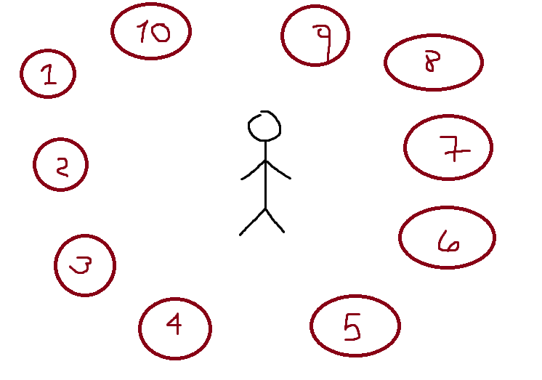
Important points :
- The spawns will have to always be orbiting around the player and following him.
- The spawns will have a Scalable and modifiable spawn rate.
- The spawns will have to be at a certain distance from the player (playtesting).
- The spawns must have a random generated number that dictates from which spawn point the next enemy will rise, and which enemy rises.

Zone Spawner
This spawner activates only when the player is in a certain zone by a trigger, it will spawn a fixed amount of enemies in a specific area that is not connected to the player itself and it will be disabled until the next overheat cycle. This spawner serves the purpose of an “ambush” in a zone where the player is actively seeking a certain enemy on the floating islands.
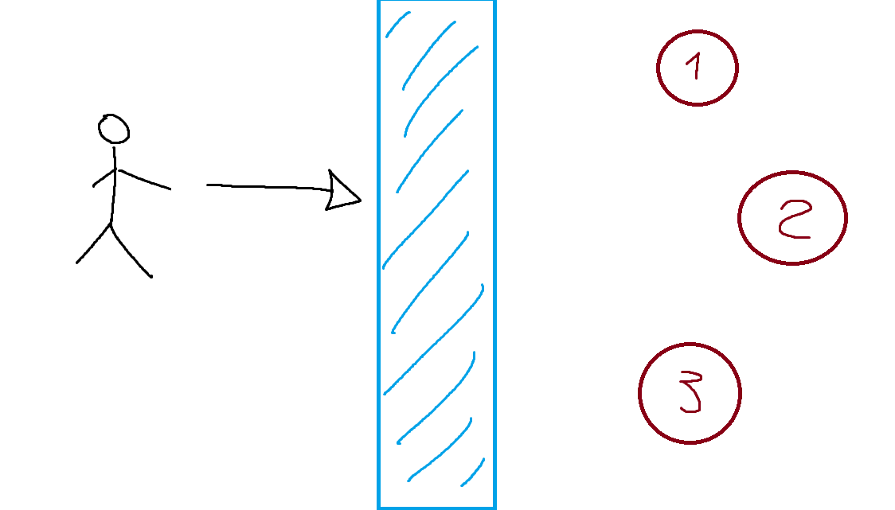

Important points :
- The spawns will have a fixed position.
- The spawns will only instantiate enemies when the player touches the trigger.
- The spawns will have to be at a certain distance from the trigger (playtesting).
- The spawns must have fixed enemies, it will not continuously spawn.
- The spawns can only activate once every overheat.

Boss Spawner
This spawner is only activated via the overheating mechanic benign at 100% , the boss can only spawn on even overheating cycles (supposing the starting number is 1). This spawner will always be located on the lower zone of the map, in the giant dumpster and can only spawn one boss at a time.
Important points :
- The spawn will have a fixed position.
- The spawn will only instantiate the boss every even overheat cycle.
- The spawn will have to be at a fixed position on the lower dumpster (playtesting).
- The spawn must have fixed Boss , it will not continuously spawn.
- The spawn can only activate once every two overheats.

Enemies
Dumpster Fire will have three normal enemies, three variants and two bosses which will be sharing stats between each other.
These stats must scale with game time to make up with the progression of the player.

Enemies - Statistics
All enemies will have the following stats

Life
The total life of the enemies must scale with game time and may vary between enemy classes.

Movement speed
The movement speed of the enemies, this stat is subject to change with playtesting but will not change in game and it is not intended to be scalable.

Damage
The damage stat of all enemies, it will have to be scalable with game time.

Drop chance
The drop chance is a stat that determines when an enemy is killed if it drops an item or not.

Drop pool
The Drop pool is a stat that fires randomly when an enemy is killed AND drops an item which item will drop. This stat will vary between enemies and variants.

Spawn Chance
The spawn chance will determine which enemy will spawn on a weighted random roulette, for this first instance without playtesting words like "Frequently" or “Not so frequently” will describe this stat.

Common Enemies

Junk Slime
This is a simple Melee type enemy, just a slime of scrap and trash that will follow the player mindlessly at a slow pace, the slime will hurt the player upon contact. Alone is harmless but in groups will be a big problem for the player.

Slime stats
- Life = Low
- Movement Speed = Low
- Damage = Low
- Drop chance = Low to medium.
- Drop pool = Sheet metal 95%, Jellified fuel 5%
- Spawn chance = Frequent and in big numbers, 10 slimes at a time.

Vigilance Drone
This enemy is a flying type, it will not follow the player to seek melee damage, instead it will detect the player and seek a minimum distance to strike a ranged shot on the actual position of the player.
The drone will not shoot instantly to the player but instead will stare at it “locking” the shot for a fixed amount of time to shoot a bullet on the last saved player position.
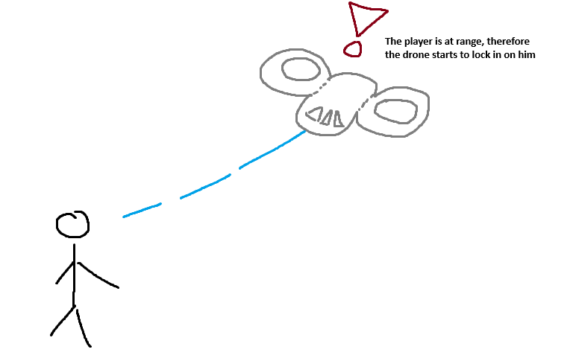
Because this enemy is a flying type unit, it will have its own stats that may share with other units that share this trait.

Drone stats
- Life = Low to medium.
- Movement Speed = Medium.
- Damage = Medium.
- Lock in distance = 3 meters from the player, subject to change upon playtesting.
- Lock in state = 3 seconds, subject to change.
- Drop chance = Medium to high.
- Drop pool = Gears 95%, Plastic explosive 5%.
- Spawn chance = Not as frequent as the slime. but in pairs of three.

Chaser Bot (Wall-e)
This is a melee type enemy, It will be a robot crafted with the sole purpose of chasing and killing the player and will have an exclusive mechanic attached to it.

The Chaser Bot, contrary to the Junk Slime, will follow the player at increased pace and if a certain distance is reached it will hold still and begin to charge a super fast dash.
This dash will increase the movement speed and the damage of the Chaser Bot, if it hits, it will push the player a certain distance. If it could not reach the player after 5 seconds it overheats and has a greatest reduction in movement speed.
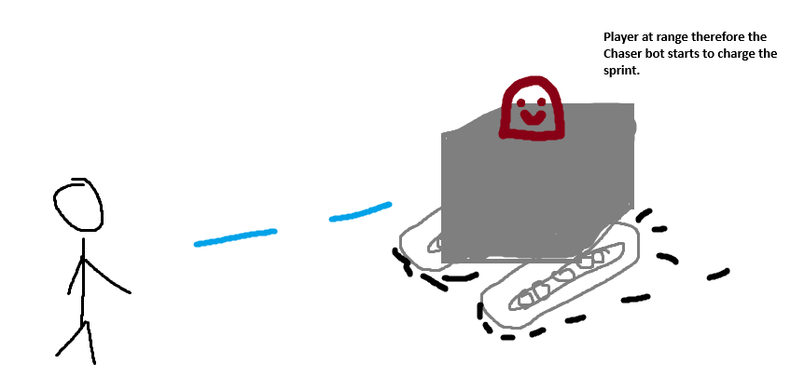

Chaser Bot stats
- Life = Medium.
- Movement Speed = High.
- Damage = Medium normal state, high in rush state.
- Push distance = 10 meters or the equivalent in force.
- Lock in distance = 5 meters from the player, subject to change upon playtesting.
- Lock in state = 5 seconds, subject to change.
- Drop chance = Medium.
- Drop pool = Metal pipe 95%, Wiring 5%.
- Spawn chance = Not as frequent as the drone . but will spawn five of them.

Enemy Variants
Dumpster Fire will have three enemy variants which elevates the threat of the regular enemies, making it harder to kill or even more deadlier. Until today (21/5/2026) there is not a certain condition which the variants will spawn.

Hellfire Slime
The Hellfire Slime, a melee type unit and the cousin of the regular slime, this little buddy just happens to fall on a pit of fire and is very angry, and green, it burns in green fire.
Jokes aside, the Hellfire Slime will seek the player just like his counterpart with the exception that, upon reaching a certain range between him and the player it will turn completely untargetable and invincible, launch forward to the player and EXPLODE leaving a fire area on the ground for a fixed amount.
Also it will burn the player for 3 seconds, a low amount of damage.

IMAGE TBD porque no puedo dibujar en la notebook.

Hellfire Slime stats
- Life = Medium
- Movement Speed = Low
- Damage = High explosion, low burn.
- Drop chance = Medium.
- Drop pool = Sheet metal 40%, Jellified fuel 60%
- Spawn chance = TBD.

Bomber Drone
The Bomber drone is a flying type unit and just what it seems, a drone with bombs. This drone will have a different behaviour compared to his counterpart.
This Drone will chase the player and dash three times in his direction throwing five C4 explosives on the ground in a line that explodes upon contact, after those three dashes it will behave like the original drone until it recharges the bombs again (maybe 5 seconds of cd).

IMAGE TBD por cosas de notebook cuando lo lean pidanme las imagenes si me olvide

Bomber Drone stats
- Life = Medium.
- Movement Speed = Medium, High when dashing.
- Damage = Medium (Shot), High (C4 explosives).
- Lock in distance = 3 meters from the player, subject to change upon playtesting.
- Lock in state = 3 seconds, 3 dashes, subject to change.
- Drop chance = Medium.
- Drop pool = Gears 40%, Plastic explosive 60%.
- Spawn chance = TBD.

Shocker Bot
The Shocker Bot is the stronger brother of the Chaser, it is highly dangerous in small numbers with its high voltage charge.
His behaviour is not far from the chaser, it will do the same but at a higher speed and being overcharged, this means that if the Shocker crash the player it will deal the same knockback effect but with a high voltage discharge that will deal extra damage and stun the player for a fixed time.
If the Shocker crashes with the player it will discharge and be on cooldown for a fixed amount of time.

IMAGEN TBD GENTE SALUDOS SALUDOS

Shocker Bot stats
- Life = High.
- Movement Speed = Sonic gotta go fast.
- Damage = Medium normal state, high in rush state plus medium explosion damage.
- Push distance = 10 meters or the equivalent in force.
- Lock in distance = 3 meters from the player, subject to change upon playtesting.
- Lock in state = 2 seconds, subject to change.
- Drop chance = Medium.
- Drop pool = Metal pipe 40%, Wiring 60%..
- Spawn chance = TBD.

Elites enemies
Elite enemies are the same normal or variant enemies with a boost in scalable base stats of 100%. These elite enemies will have a check before the normal enemies spawn in order to have a better control on when the Elites will appear.
Some spawn points will spawn ONLY elites.

Bosses
Bosses will be unique enemies that spawn between overheats and are crucial to the player progression, these bosses will have attack patterns that challenge the player in order to obtain the power cells.

Giga worm
This Boss will be a giant worm capable of attacking the player from underground and spit a volley of corrosive slime.
The giga worm will behave like a hunter, it will remain underground waiting to strike the player from below, the desired behaviour will be something like the dune worms that sense the character vibrations and locate its position.

Behaviour
Phase 1:
The worm will spawn randomly when the even overheat stage is active. It will spawn underground and must have an area ground effect when it moves, like a bunch of junk moving and jumping from the ground.

Phase 2:
When the worm is underground it is completely untargetable and damagable except from Dot damage. It will move underground following the player movement when it's touching the same ground as the worm and after a few seconds will create a circle under the current player position in order to jump and attack.

Phase 3:
The attack will damage the player and push it in a different direction of where it's currently in, the worm will jump in a parable shape and spit while it's in the air to the player and its surroundings, creating a slowing zone around the spited area.

